Scientific Sensor Data Manager
Prototype Report
Version <1.0>
Document Control
Approval
The Guidance Team and the customer shall approve this document.
Document Change Control
Initial Release: | 1.0
Current Release: | 1.0
Indicator of Last Page in Document: | ∑
Date of Last Review: | 04/18/2013
Date of Next Review:
Target Date for Next Update:
Distribution List
This following list of people shall receive a copy of this document every time a new version of this document becomes available:
Guidance Team Members:
Dr. Ann Gates
Omar Ochoa
Luis Garcia
Customer: Dr. Deana Pennington and Dr. Salamah Salamah
Joseph Aguirre
Andre De La Cruz
Arturo Delgado
Juan Rodriquez
Jesus Tabares

Table of Contents
Document Control ii
Approval ii
Document Change Control ii
Distribution List ii
1. Introduction 4
1.1. Purpose and Intended Audience 4
2. Clients 4
2.1. Dr. Deana Pennington 4
2.2. Dr. Salamah Salamah 4
3. System Features 5
3.1. Login 5
3.2. Map and Search 6
3.3. File Format 7
3.4. Playlist, Edit Data Property, Remove Data Property and History of Change 8
3.5. Preferences 10
3.6. Set Scope, Set Pattern, Graph, Create Data Property, Track, and Show Anomaly 11
4. Traceability Matrix 13
4.1. Matrix 13

Introduction

Purpose and Intended Audience
The purpose of this document is to report the traceability of the requirements that where represented on our prototype that was demonstrated on April 9, 2013. The prototype of our system contains features and functions that where identified by the client. Our report will trace those requirements to the interview report.

Clients

Dr. Deana Pennington
Dr. Pennington introduce our development team to the propose system. During her interview report it was essential that system reported anomalies based on the data properties that where created by the scientist. Dr. Pennington wanted the system to alert the scientist so the scientist can determine the next course of action. Dr. Pennington also discussed the system should represent the data visually to the user for instance graphing and be able to print. Visualizing the data is also a critical characteristic of our system and this was transpose on our prototype.

Dr. Salamah Salamah
Dr. Salamah gave our development team an in depth introduction to data properties and how they are utilize. The data properties consist of a scope, pattern and a dataset over time. Dr. Salamah provided five distinct scopes that are use and their potential results. Anomalies are depended on what the data properties consist of and their results.

System Features

Login

Log in screen that will let the user log in. The user can also choose "forgot password" or "forgot username" which will provide them with the ability to retrieve their credentials.

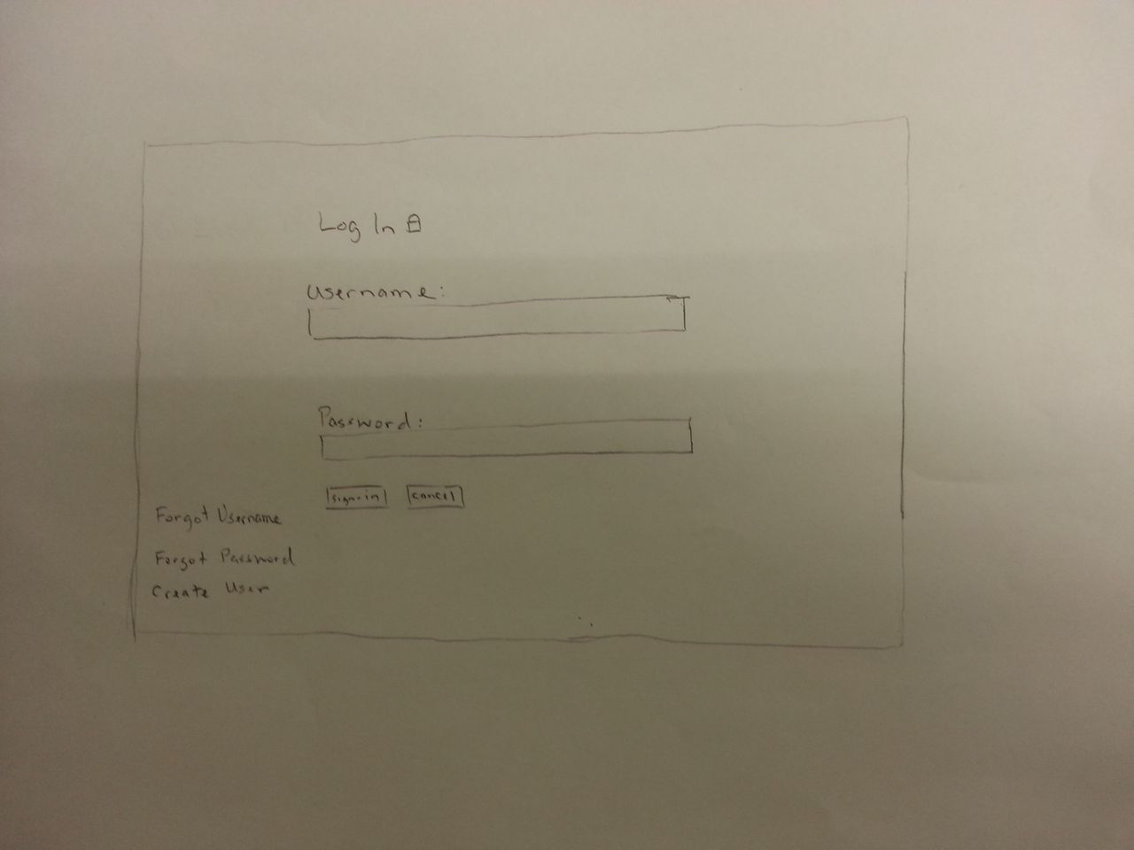

Requirements to Login:
SR4.

Map and Search

Map
This page contains a map that the user will use to hone in on the location of the sensors around the world. Once narrowed down to the smallest region, the user can choose a list of sensors and select which one they would like to view data on.

Search
The user can select to search sensors by location, type, and sensor data.

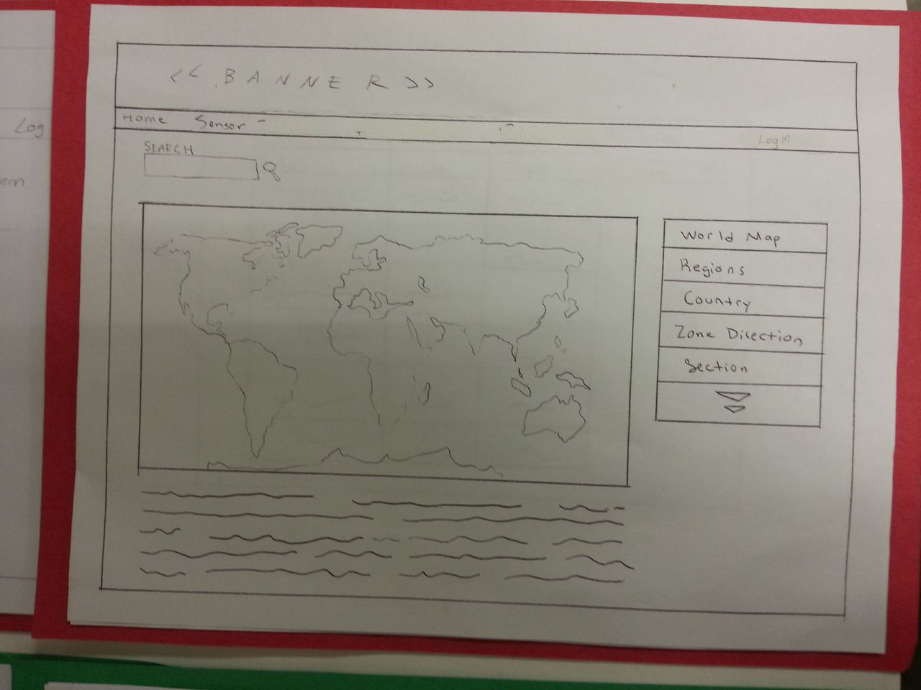
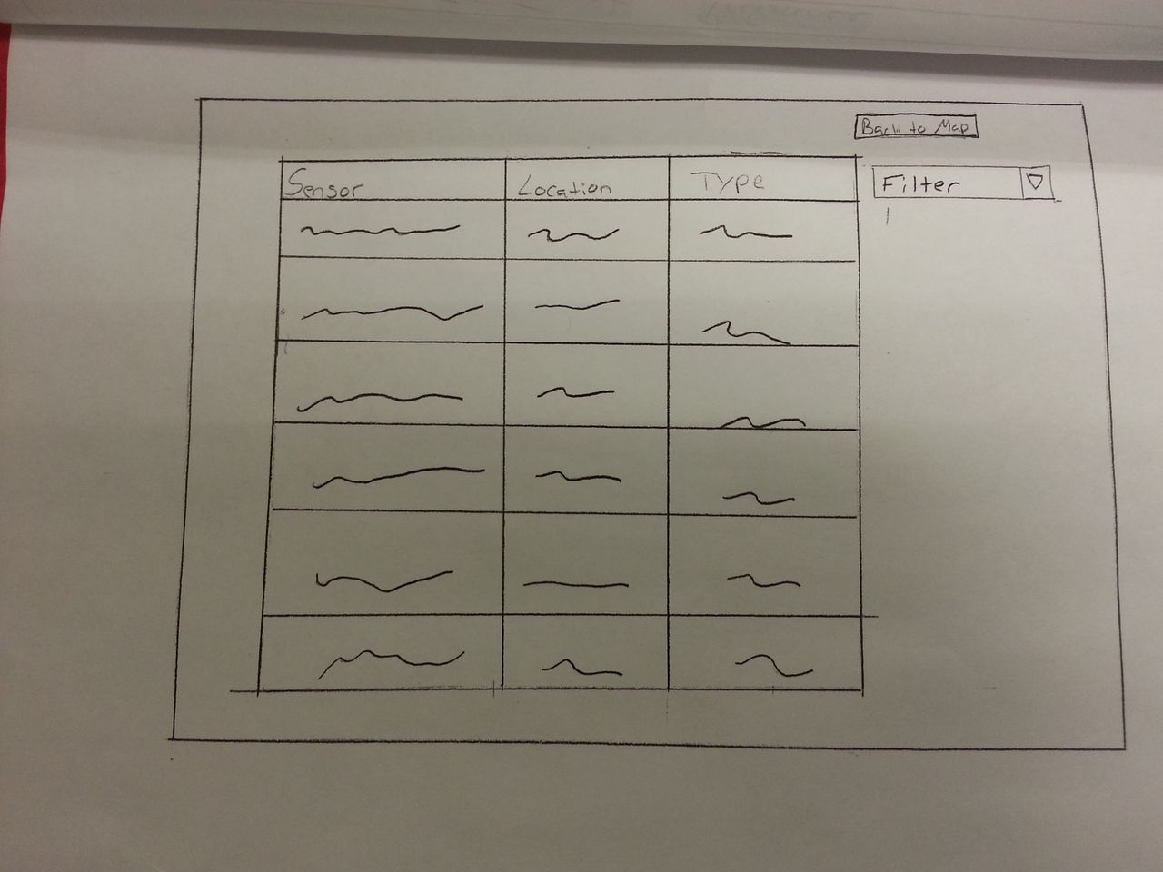

Requirements to Map:
SR18 and SR36.

File Format

A list of all the data properties associated with the user. The list will include properties that the user has created and will also contain ones that they have selected to track. Guest users will not be able to use this function.

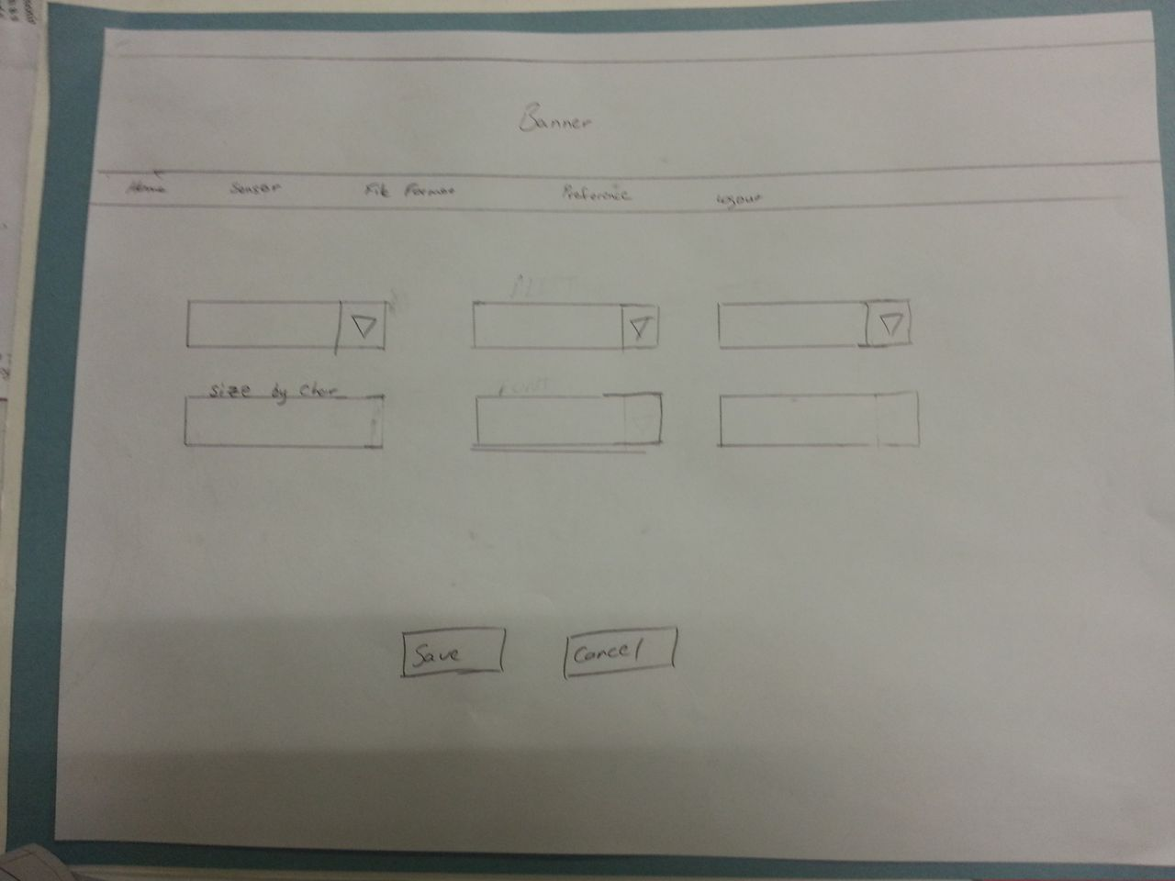

Requirements to File Format:
SR20 and SR21.

Playlist, Edit Data Property, Remove Data Property and History of Change

Playlist
A list of all the data properties associated with the user. The list will include properties that the user has created and will also contain ones that they have selected to track. Guest users will not be able to use this function.

Edit Data Property
The user can choose to edit some of the data properties they have created. They can choose a new scope, pattern, or new measurement. Guest users will not be able to use this function.

Remove Data Property
The user can decide which data property they would like to remove. They can remove the ones they have created however if they choose one that the user has been tracking, it will only be removed from their playlist. Guest users will not be able to use this function.

History of Change
Every time a user creates a data property, it will be recorded who created it and who they are affiliated with.

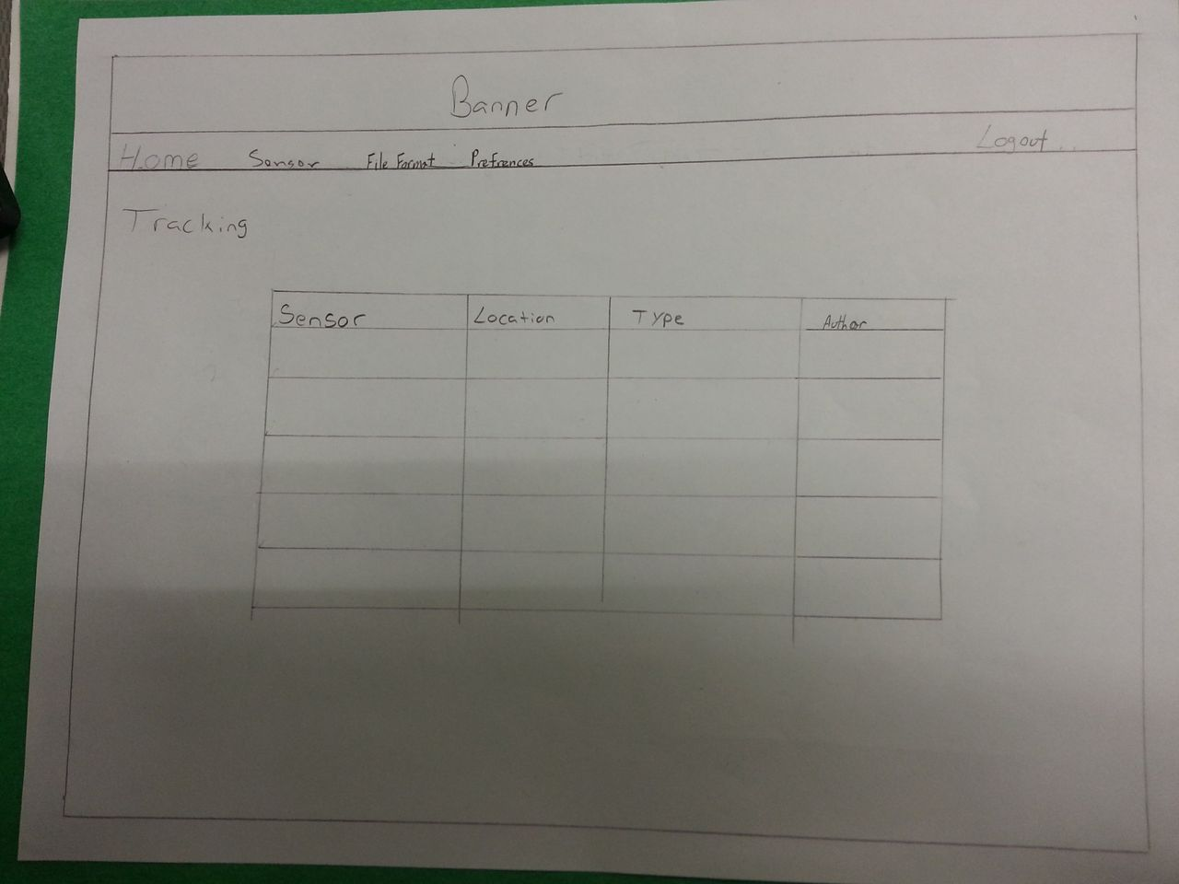

Requirements to the Playlist:
SR9.

Requirements to the Edit Data Properties:
SR2 and SR44.

Requirements to the Remove Data Properties:
SR46.

Requirements to the History of Change:
SR6, SR7 and SR45.

Preferences

The user can use this page to edit their account. They can choose a new password, change their email, change the affiliation, change their phone number, and also choose how they would like to be alerted if an anamoly were to occur. Guest users will not be able to use this function.

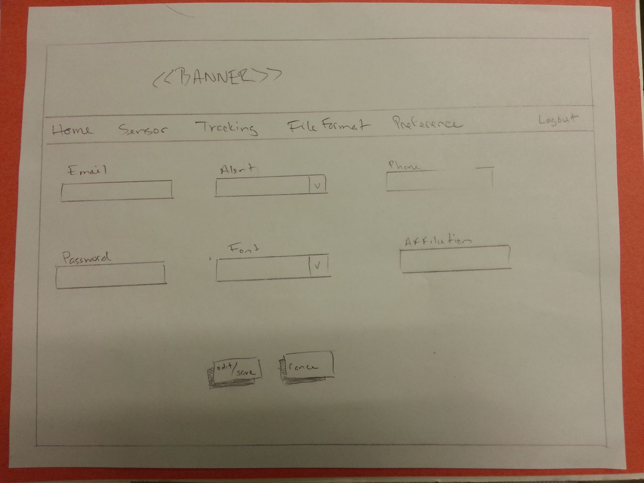

Requirements to the Preference:
SR46 and SR55.

Set Scope, Set Pattern, Graph, Create Data Property, Track, and Show Anomaly

Set Scope
Under the graph there will be five radio buttons representing the different scopes that can be selected. Depending on the scope selected zero or more text fields will appear which will allow the user to specify the range of the scope.

Set Pattern
While creating a new data property a scroll down menu which contains all selectable patterns will allow for user to apply patterns to the selected graph. Under the pattern selection will be three boxes one will show the type of data being measured from the sensor. The second will contain mathematical relation symbols (<,>,=,<=,>=,<>), The third will contain the text field where the user can input the value of interest.

Graph
This feature displays all the data for the sensors. The user can select which type of graph they would like to use such as a line, bar, pie or select to view the raw data, which will turn the graph into a list containing the data. On a side bar, the user can select which data properties he or she would like to view. Once a property is chosen the graph will auto adjust to the scope and info already defined. Any anomalies will be shown on the graph with a marker.

Create Data Property
The user will set a scope and pattern to create a new data property. They can also choose to set the created data property as private or as public.

Track
The user will be able to select a data property from a list associated with that sensor. The graph will change according to what they specify. Under the graph there will be some text fields with the data of the already existing data property. The user can select track which will add the already existing data property into their "playlist". Guest users will not be able to use this function.

Show Anomaly
Anomalies will be shown as a marker on the graph and on a side bar with all the information associated with it.

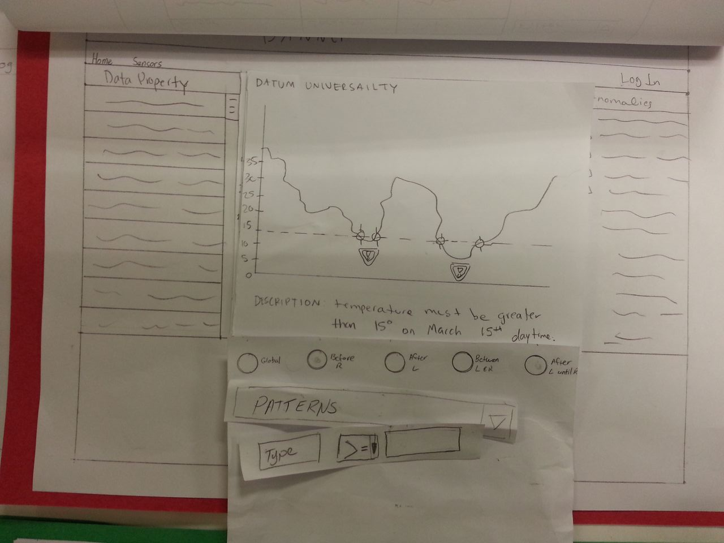
Requirements to the Set Scope:
SR13, SR15, SR22, SR23, SR24, SR25, SR26, SR40 and SR49.

Requirements to the Set Pattern:
SR26, SR27, SR28, SR29, SR30 and SR40.

Requirements to the Graph:
SR9, SR12, SR13, SR14 SR16 and SR19.

Requirements to the Track:
SR31, and SR43.

Traceability Matrix

Matrix

The following matrix correlates the system requirements and features on the prototype. The left column contains the detailed requirements gathered from the interview report, project description, and memos. The top row contains the features of the system included on the prototype.





